**HEAT Image types and their patterns**

1. A thermal camera mounted on a drone has been used for the first time in the solar farm operating conditions of India to capture images of the solar field and investigate solar panels for defective cells and create an Ortho mosaic image of the entire area.
2. The defects in solar cells were identified with the use of thermal bands, which record and point out their temperature of them.
3. PVs convert sunlight into electricity using semiconducting materials that absorb photons and generate electrons.
4. The series string is laminated to the backing material, sealed in a weatherproof plastic coating, and covered by a glass on top, often with an aluminum frame around the edges. This assembly is called the photovoltaic module.
5. The most common PV inspection techniques are visual inspection, I-V (current-voltage) measurement testing, which is applied in order to extract the characteristic I-V curve of a particular PV module, electroluminescence imaging, infrared thermography, which uses thermal cameras to capture the heat radiation of the cells and convert it into electrical signals.

**Pattern of thermal image of defective panels:**

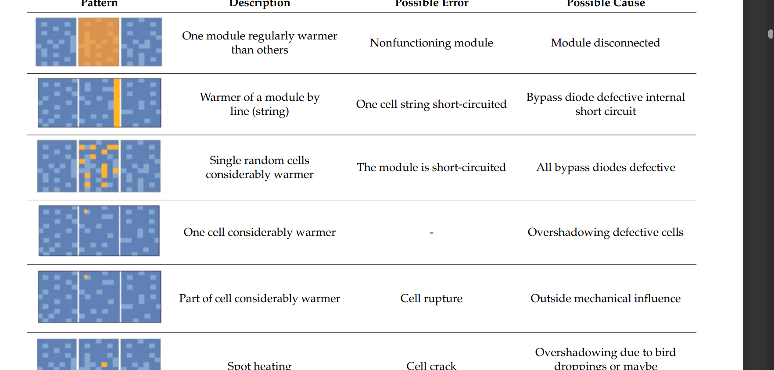

**Thermal Image “DJI_0002_R”. An example of a visual display:**

The shading that affects PV cells and leads to hotspot creation can be caused by bird droppings, leaves, and dust, which suspend the cells’ function and prevent the current generated from other cells.

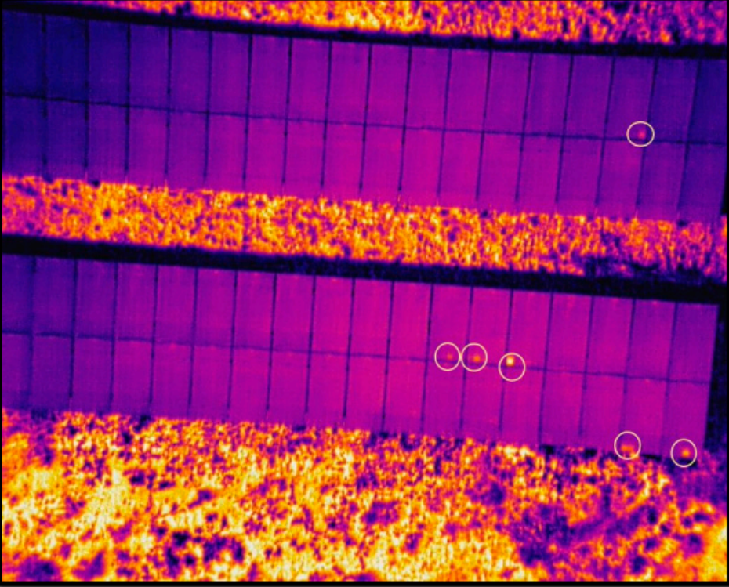

**How to do it with YOLO 5 or 9:**

YOLO V5 can be applied to Solar Photovoltaic Hotspot Inspection by utilizing object detection methods such as anchor boxes, object tracking, and object segmentation. Anchor boxes can be used to detect and classify objects of interest within the thermal images, such as damaged solar panels, cracks, and other areas of concern. Object tracking can be used to identify the position and area of these objects over a period of time. Lastly, object segmentation can be utilized to trace objects against their backdrop, allowing for improved accuracy and providing a more informative inspection of potential hotspots**.**

YOLOv5, not only can relevant hotspots be located, but through the inclusion of thermal imagery, temperatures of these areas can also be ascertained. This can further provide clues concerning what kind of damage or defect the image is depicting, enabling effective and efficient solar photovoltaic inspection.